S.D. State University Earns Top Honors at Collegiate Dairy Contest
Sep 18, 2015
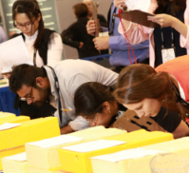
Contact: Marti Pupillo
(202) 220-3535
mpupillo@idfa.org
(Chicago – September 17, 2015) South Dakota State University students garnered all top honors at the 94th Collegiate Dairy Products Evaluation Contest held this week in conjunction with the International Dairy Show in Chicago. The University earned its ninth consecutive All Products team title, while students Nicole Jax captured first place in the All Products undergraduate category and Dikshi Bawa earned the top spot in the graduate category.
Twelve schools from the United States and Canada participated in this year’s contest. In addition to South Dakota State University, 10 U.S. colleges and universities competed: Clemson University, Iowa State University, Michigan State University, Pennsylvania State University, the University of Missouri, the University of Minnesota, the University of Tennessee, the University of Wisconsin, Washington State University/University of Idaho and Aims Community College in Colorado. Canada was represented by The University of Alberta.
The Clemson University team placed second in the All Products category, and the University of Tennessee team took third place.
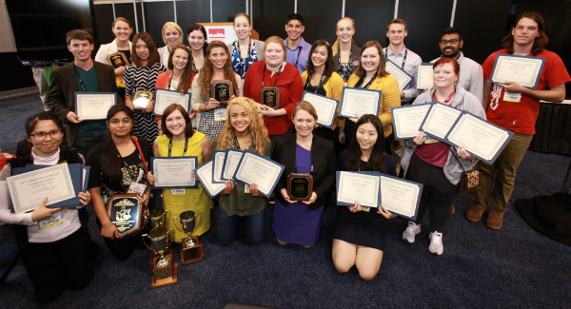
Sensory Quality of Retail Dairy Products
Established in 1916 by several universities, the Collegiate Dairy Product Evaluation Contest initially was designed to identify quality defects in dairy products throughout the country so they could be corrected. It expanded over the years to recognize those students and dairy product judging teams that had mastered the ability to identify high-quality dairy products. The contest gives students the opportunity to showcase their evaluation skills and prepare for careers in the dairy industry.
Students tested their palates against professional judges in six different dairy products, fluid milk, butter, yogurt, cheddar cheese, ice cream and cottage cheese. To begin, judges review eight representative samples of the six different dairy products and render judgments on each of dozens of possible attributes and the severity of their departure from the ideal. Students then are challenged to present scorecards with answers that come as close as possible to the judgments of the experts.

All Products Winners
In the All Products individual undergraduate category, Nicole Jax of South Dakota State University won first place, Valerie Nettle of the University of Tennessee earned the second place award Kinsey MacDonald of Clemson University won third place.
In the All Products individual graduate student category, Dikshi Bawa of South Dakota State University won first place. Carrie Yard of the University of Tennessee earned the second place award, and Kangzi Ren of Iowa State University won third place.

Product Category Winners
First-, second- and third-place winners were named in each of the six product categories. The undergraduate winners are:

Milk
- First place: Lindsey Jenkinson, Clemson University
- Second place: Nicole Jax, South Dakota State University
- Third place: James Strelow, University of Wisconsin
Butter
- First place: Katherine Lowe, Iowa State University
- Second place: Nicole Jax, South Dakota State University
- Third place: Paige Lindquist, Clemson University

Yogurt
- First place: Kinsey McDonald, Clemson University
- Second place: Nicole Jax, South Dakota State University
- Third place: Valerie Nettle, University of Tennessee

Cheddar Cheese
- First place: Kaylee Wagner, South Dakota State University
- Second place: Valerie Nettle, University of Tennessee
- Third place: Eleanor Miller, University of Wisconsin

Ice Cream
- First place: Yingxin Zhong, University of Minnesota
- Second place: Kaylee Wegner, South Dakota State University
- Third place: Valerie Nettle, University of Tennessee

Cottage Cheese
- First place: Lauren Celmer, Washington State University/Idaho State University
- Second place: Nicole Jax, South Dakota State University
- Third place: Adam Berge, University of Missouri
The graduate student winners are:

Milk
- First place: Hong Jiang, University of Wisconsin
- Second place: Geoff Dubrow, University of Minnesota
- Third place: Kangzi Ren, Iowa State University

Butter
- First place: Amy Haile, Clemson University
- Second place: Dikshi Bawa, South Dakota State University
- Third place: Geoff Dubrow, University of Minnesota

Yogurt
- First place: Carrie Yard, University of Tennessee
- Second place: Hong Jiang, University of Wisconsin
- Third place: Dikshi Bawa, South Dakota State University

Cheddar Cheese
- First place: Zachary Cartwright, Washington State University/University of Idaho
- Second place: Carrie Yard, University of Tennessee
- Third place: Kangzi Ren, Iowa State University

Ice Cream
- First place: Dikshi Bawa, South Dakota State University
- Second place: Abhi Datta, University of Missouri
- Third place: Zachary Cartwright, Washington State University/University of Idaho

Cottage Cheese
- First place: Hannah Damiano, Washington State University/University of Idaho
- Second place: Zachary Cartwright, Washington State University/University of Idaho
- Third place: Dikshi Bawa, South Dakota State University
To learn more about this unique competition, visit www.dairyproductscontest.org.

