South Dakota State University Claims Team Win at 2018 Collegiate Dairy Contest
April 23, 2018

Contact: Vanessa Teter
(203) 490-1387
vanessa.teter@dannon.com

(Madison – April 18, 2018) South Dakota State University took the All Products honors at the 96th Collegiate Dairy Products Evaluation Contest (CDPEC) held April 18th in conjunction with the Wisconsin Cheese Industry Conference hosted by the Wisconsin Cheese Makers Association. South Dakota State University student Megan Struss was the All Products winner while Taylor Harper (University of Missouri) claimed the Graduate Student All Products category.
Fourteen colleges and universities from the United States and South Korea participated in this year’s contest. In addition to South Dakota State University, schools competing at the contest were, Aims Community College in Colorado, California Polytechnic State University, Clemson University, Cornell University, Iowa State University, Michigan State University, Pennsylvania State University, the University of Minnesota, the University of Missouri, The University of Tennessee, the University of Wisconsin, Washington State University/University of Idaho and South Korea was represented by Seoul National University.
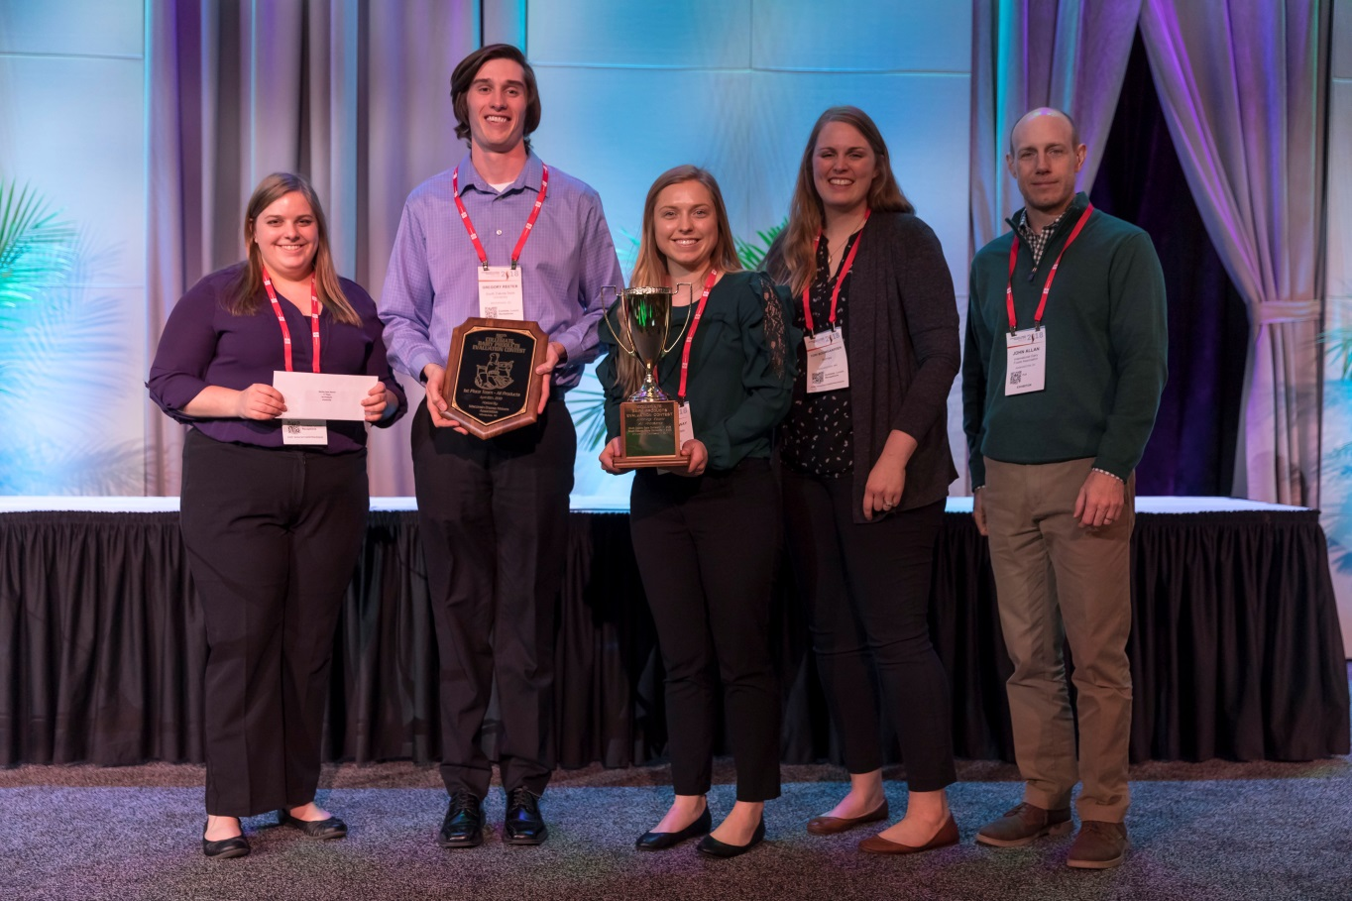
Clemson University, for the second year in a row, placed second in the All Products category, while the University of Tennessee took third. And taking first for the All Products Team Win was South Dakota State pictured below. South Dakota State University’s team is coached by Dr. Lloyd Metzger and Bennet Baker.

2018 All Products Winning Team – SDSU – Pictured from left to right: Megan Struss (1st Place All Products, SDSU), Greg Reeter (3rd Place All Products, SDSU), Anna Hemenway (2nd Place Yogurt, SDSU), Tori Boomgaarden (Kemps LLC, Contest Coordinator) and John Allen (IDFA, Contest Sponsor).
Sensory Quality of Retail Dairy Products
Established in 1916 by several universities, the Collegiate Dairy Product Evaluation Contest initially was designed to identify quality defects in dairy products throughout the country so defects could be corrected. It expanded over the years to recognize those students and dairy product judging teams that had mastered the ability to identify high-quality dairy products. The contest gives students the opportunity to showcase their evaluation skills and prepare for careers in the dairy industry.
Students test their sensory abilities against professional judges in six different dairy products: fluid milk, butter, yogurt, cheddar cheese, ice cream and cottage cheese. Dairy industry judges from around the country review eight representative samples of the six different dairy product categories and score each sample based on sensory attributes and the severity of their departure from the ideal. The students are challenged to present scorecards with answers that come as close as possible to the judgments of the experts.

All Products Winners
In the All Products individual undergraduate category, Megan Struss of South Dakota State University won first place, Kaylie Senn of Clemson University earned the second place award and Greg Reeter of South Dakota State University won third place.
In the All Products individual graduate student category, Tyler Harper of the University of Missouri won first place, Trenton Kerley of the University of in second place and Jaya Banjade from the University of Minnesota taking third place.

Product Category Winners
First, second and third place winners (and Team Category winner) were named in each of the six product categories. The winners are as follows:
Butter
3rd Place, Allison Shaunak from the University of Tennessee
2nd Place, Anna Hemenway from South Dakota State University
1st Place, Greg Reeter from South Dakota State University

Graduate Winner, Melanie Franks from Cornell University

Overall Team Winner – South Dakota State University

Cheddar Cheese
3rd Place, Sarah Hansen Iowa from Clemson University
2nd Place, Emily Kirisits from the University of Missouri
1st Place, Reanna Cummings from the University of Tennessee

Graduate Winner, Ana Karina Garcia from California Polytechnic State University

Overall Team Winner – University of Tennessee

Cottage Cheese
3rd Place, Caroline Cate from the University of Tennessee
2nd Place, Sarah Hansen from the Iowa State University
1st Place, Reanna Cummings from the University of Tennessee

Graduate Winner, Sonali Raghunath from the University of Minnesota

Overall Team Winner – University of Tennessee

Ice Cream
3rd Place, Jonathan Counts from the University of Idaho
2nd Place, Caroline Cate from the University of Tennessee
1st Place, Kaylie Senn from Clemson University

Graduate Winner, Ahmed Hammam from South Dakota State University

Overall Team Winner – South Dakota State University

Milk
3rd Place, Megan Struss from South Dakota State University
2nd Place, Kaylie Senn from Clemson University
1st Place, Jonathan Dillard from Clemson University

Graduate Winner, Jaya Bangade from the University of Minnesota

Overall Team Winner – Clemson University

Yogurt
3rd Place, Anna Hemenway from South Dakota State University
2nd Place, Greg Reeter from South Dakota State University
1st Place, Kaylie Senn from Clemson University

Graduate Winner, Trenton Kerley from the University of Tennessee

Overall Team Winner – South Dakota State University

All Products Individual/Team
3rd Place, Greg Reeter from South Dakota State University
2nd Place, Kaylie Senn from Clemson University
1st Place, Megan Struss from South Dakota State University

Graduate Winner, Taylor Harper from the University of Missouri

Overall Team Winner – South Dakota State University

To learn more about this unique competition, visit www.dairyproductscontest.org.

